Question 1:

#include <stdio.h>

int linear_search(int arr[], int n, int target) {

for (int i = 0; i < n; i++) {

if (arr[i] == target) {

return i;

}

}

return -1;

}

int main() {

int arr[] = {1, 3, 5, 7, 9};

int n = sizeof(arr) / sizeof(arr[0]);

int target = 5;

int result = linear_search(arr, n, target);

if (result != -1) {

printf("Element %d found at index %d.\n", target, result);

} else {

printf("Element %d not found.\n", target);

}

return 0;

}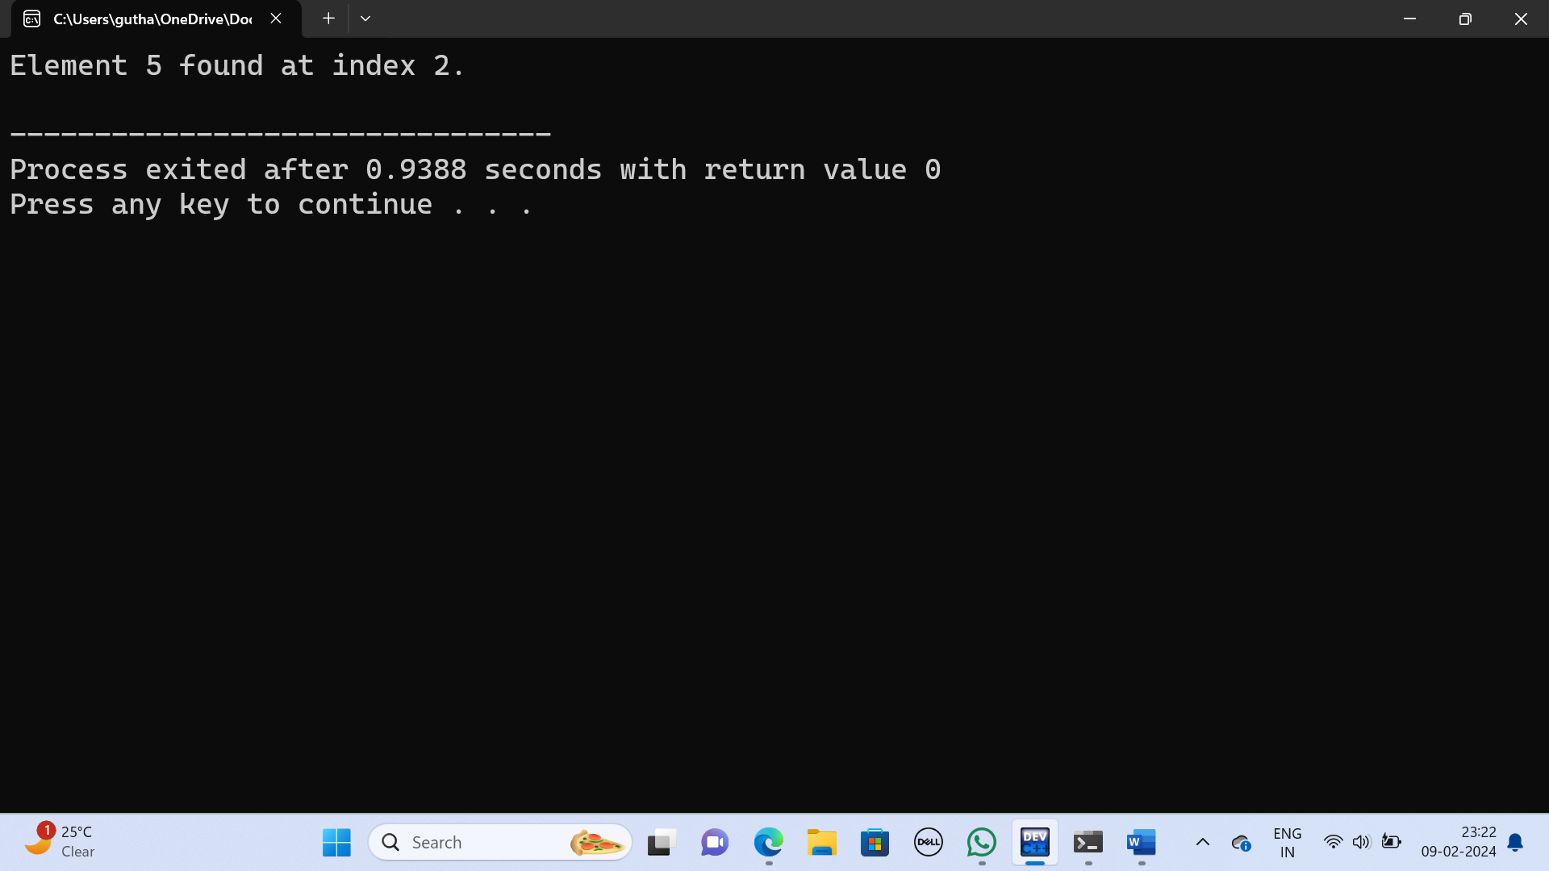

Question 2:

#include <stdio.h>

int binary_search(int arr[], int left, int right, int target) {

while (left <= right) {

int mid = left + (right + left) / 2;

if (arr[mid] == target)

return mid;

if (arr[mid] < target)

left=mid+1;

else

right = mid - 1;

}

return -1;

}

int main() {

int arr[] = {1, 3, 5, 7, 9};

int n = sizeof(arr) / sizeof(arr[0]);

int target = 5;

int result = binary_search(arr, 0, n - 1, target);

if (result != -1) {

printf("Element %d found at index %d.\n", target, result);

} else {

printf("Element %d not found.\n", target);

}

return 0;

}